Ashvin
Requirements Document v1.5
[TODO: Get the Ashvin logo into its usual font]

Adviser: | Sunny Wong
Stakeholder: | Siemens Healthcare / Robert Neff
Group Members: | Brian Courtney
 | Daniel Huynh
 | Daniel Molander
 | Michael McLaughlin
 | Sunny Patel

Table of Contents
1 Document Information 1
1.1 General Information 1
1.2 Revision History 2
1.3 Related Documents 3
2 Introduction 4
2.1 Purpose 4
2.2 Definition of Terms 4
2.3 Overview 6
2.4 Scanning Technology 6
2.5 Scope 6
3 Functional Requirements 7
3.1 Requirements Priority Scheme 7
3.2 Graphical User Interface (GUI) 8
3.2.1 Launching the Client Application 9
3.2.2 System Set Up 10
3.2.2.1 Camera Set Up 10
3.2.2.2 Server Set Up 11
3.2.3 Display of Information 12
3.2.3.1 Patient Information 12
3.2.3.2 Patient Prescription 13
3.2.3.3 Input of Medication into System 15
3.3 User Stories 16
3.3.1 Launching the Server Application 16
3.3.2 Launching the Client Application 17
3.3.3 Assignment of Electronic Health Record (EHR) Source 18
3.3.4 Assignment of Video Source 19
3.3.5 Scanning a Patient into the Client 20
3.3.6 Scanning Medication into the Client 21
3.3.7 System Alerts 22
3.3.7.1 System Scans Object but Can Not Identify as a Patient or Medication 22
3.3.7.2 System Scans Patient but No Such Patient Exists in the EHR 23
3.3.7.3 System Scans Medication but No Such Medication Exists in the EHR 24
3.3.7.4 System Detects Incorrect Match to Medication vs. Prescription 25
3.3.7.5 System Detects Incorrect Match to Medication Dose vs. Prescription 26
3.3.7.6 System Detects Incorrect Match of Medication Route vs. Prescription 27
3.3.7.7 System Detects Incorrect Match to Time Administered vs. Prescription 28
3.3.7.8 System Detects Incorrect General Route 29
3.3.7.9 System Detects Correct General Route but Incorrect Specific Route 30
4 Non Functional Requirements 31
4.1 Security 31
4.2 Reliability 31
4.3 Durability 31
4.4 Speed 31
4.5 Portability 31
4.6 Expandability 31
4.7 Testability 31
4.8 Documentation 32
4.8.1 Design Document 32
4.8.2 User Manual 32
4.8.3 Administrative Manual 32
5 System Evolution 33

Table of Figures
Figure 1 : Ashvin GUI Flow Diagram 8
Figure 2 : Ashvin Start Up 9
Figure 3 : Camera Settings Page 10
Figure 4 : Server Settings Page 11
Figure 5 : Patient Information Tab (Expanded View) 12
Figure 6 : Patient Prescription Tab 13
Figure 7 : Drug Icon Pop Up Dialog 14
Figure 8 : Scanning Activity Tab 15

Table of Tables
Table 1 : Ashvin Requirement Document General Information 1
Table 2 : Ashvin Requirements Document Revision History 2
Table 3 : Implementation Methods for Scanning Identification Information into an Electronic System 6
Table 4 : Functional Requirements Priority Scheme 7

Document Information

General Information
Table 1 shows general information regarding the Ashvin Requirements Document.
Version | v1.5
Title | Ashvin Requirements Document
Authors | Michael McLaughlin [TODO: Add names as authors are added]
Reviewers | [TODO: Add names as reviewers are added]
Table 1 : Ashvin Requirement Document General Information

Revision History
Table 2 shows the revision history the Ashvin Requirements Document.
[TODO: Change version number in General Information table and on title page when new version is added.]
Version | Date | Editor(s) | Comments
v1.5 | 01/03/2014 | Michael McLaughlin | Started adjusting functional requirements to match them up with the test cases being created in the Acceptance Test Plan.
v1.4 | 01/02/2014 | Michael McLaughlin | Added description of different types of scans.
v1.3 | 12/29/2013 | Michael McLaughlin | Converted functional requirement structure/use cases to user story structure. Created user stories.
v1.2 | 12/22/2013 | Michael McLaughlin | Added use cases. Restructured headings. Added priority definitions.
v1.1 | 12/20/2013 | Michael McLaughlin | Added figures in GUI section, as well as configured captioning/Table of Figures.
v1.0 | 12/17/2013 | Michael McLaughlin | Initial draft / outline of document.
Table 2 : Ashvin Requirements Document Revision History

Related Documents
The following documents contain further information related to this document.
- Ashvin abstract – Abstract Google doc. [TODO: Come up with a better source for the abstract?]
- Ashvin Acceptance Test Plan Document – Ashvin_Acceptance_Test_Plan.pdf.
- Ashvin Design Document – Ashvin_Design.pdf. [TODO: Create Document]

Introduction

Purpose
This document outlines the functional and non-functional requirements of the Ashvin nursing work flow monitoring system.

Definition of Terms
[TODO: As terms are added in the document, add and define them here. Before final submission, search the document and remove any item below that is not actually used in the document. E.g., if the term "Smart Device" is never used, remove it here.]
- Active Scanning System – Electronic system where the devices present in a patient care setting autonomously scan their environments for input without the need for a human to initiate the scanning processes. E.g., a computer program parses live camera images for barcodes and scans them into the computer on its own. See also: Passive Scanning System.
- Android – Mobile operating system (OS) maintained by Google. See also: Mobile Device, Smart Device.
- Barcode – Machine readable label placed on an object used to import data into a computer. Barcodes can be read optically via a LASER scanner or a camera.
- Electronic Health Records (EHR) System – Hospital storage system for patient information. In regards to this document, the term EHR encompasses the entire hospital records system, including, but not limited to, the database information for a given patient, along with other hardware / software that is used in the patient care process.
- Five Rights of Medication Administration – Medical industry standard for ensuring the accurate administration of medication to a patient. The rights are:
  - Right Patient
  - Right Medication
  - Right Dose
  - Right Time
  - Right Route of Administration
- Google Glass – Interactive glasses worn by a person that allows him/her to digitize the world around him/her through the use of an attached camera. The glasses also display information onto the glasses for the wearer to view as if looking at a computer monitor.
- Graphical User Interface (GUI) – Interface used by a user to graphically interact with a hardware or software system.
- Image Recognition – Technology involving optical recognition by a computer of a real world object.
- Infrared (IR) – Wavelength of light just outside of the visible range.
- Intravenous (IV) Medication Administration – Route of administering medication to a patient via the vein using a needle.
- Mobile Device – A digital device that is contained on the person of a user and is used to receive output from the EHR or video source, as well as to input information into the EHR.
- Passive Scanning System – Electronic system where the devices present in a patient care setting scan their environments for input with the help of a human being. E.g., a person explicitly clicks a button on a hand held scanner to read a barcode. See also: Active Scanning System.
- Prescription – Formal, physician implemented medication plan directly related to a given patient.
- Radio Frequency Identification (RFID) – Wireless system for passing information between objects using an RF.
- Real-time Locating Systems (RTLS) – System used to identify and track objects in a live environment. An RTLS may be implemented via RFID, IR, SONAR or other form of technology.
- RF – Radio Frequency.
- Smart Device – See Mobile Device.
- Sonic – The use of sound waves.
- Sound Navigation and Ranging (SONAR) – System for using sound propagation to detect objects in a medium such as water or air.
- User – Any person, typically a nurse, who uses the Ashvin system.

Overview
The Ashvin nursing work flow system is used to monitor a patient care setting. Th system is an RTLS that consists of one or more input technologies used to detect pertinent patient care related data that exist in a particular care setting as well as a server used to interpret the data once it is imported into the system. Ashvin focuses on the input of the patient identification, as well as the medications associated with the patient, into the healthcare information system (HIS) present in the care setting. Information on the patient and medications is detected dynamically during patient care using an electronic system accessible by the nurse on duty.

Scanning Technology
Table 3 shows a list of common technologies that are typically used to scan real time information into a computer system. Ashvin uses at minimum, one of the technologies listed in Table 3.
Barcodes
Scan Type | Description | Transfer Technology
Barcode: Passive Scan | The user explicitly scans a barcode into the client using a passive system. | Camera or LASER
Barcode: Active Scan | System autonomously scans a barcode using an active system. | Camera or LASER
RFID: Active Scan | System autonomously reads in an RFID signal using an active system. | RF
SONAR | System autonomously reads a SONAR signal into the client using an active system. | Sonic
Table 3 : Implementation Methods for Scanning Identification Information into an Electronic System

Scope
[TODO. Mention 5 rights of med. admin. here and the fact that this document focuses on no specific implementation of the scanning technology]

Functional Requirements
The Ashvin system implements, at minimum, one of the technologies defined in Table 3 of section .

Requirements Priority Scheme
Each Ashvin functional requirement is assigned a priority which dictates how important it is that the requirement be implemented. The priorities are listed and defined in Table 4.
Priority | Description
Must Have | Requirement must be successfully implemented as agreed upon by all parties before the software is released.
Should Have | Requirement is not expected to be implemented with first release but expected to be implemented with next release.
Could Have | Requirement is not judged to be in the scope of the current design. Requirement may be implemented within a future release.
Deferred | Requirement was originally judged to be in the scope of the current design but was set aside for future considerations.
Table 4 : Functional Requirements Priority Scheme

Graphical User Interface (GUI)
Figure 1 shows the Ashvin GUI flow diagram.
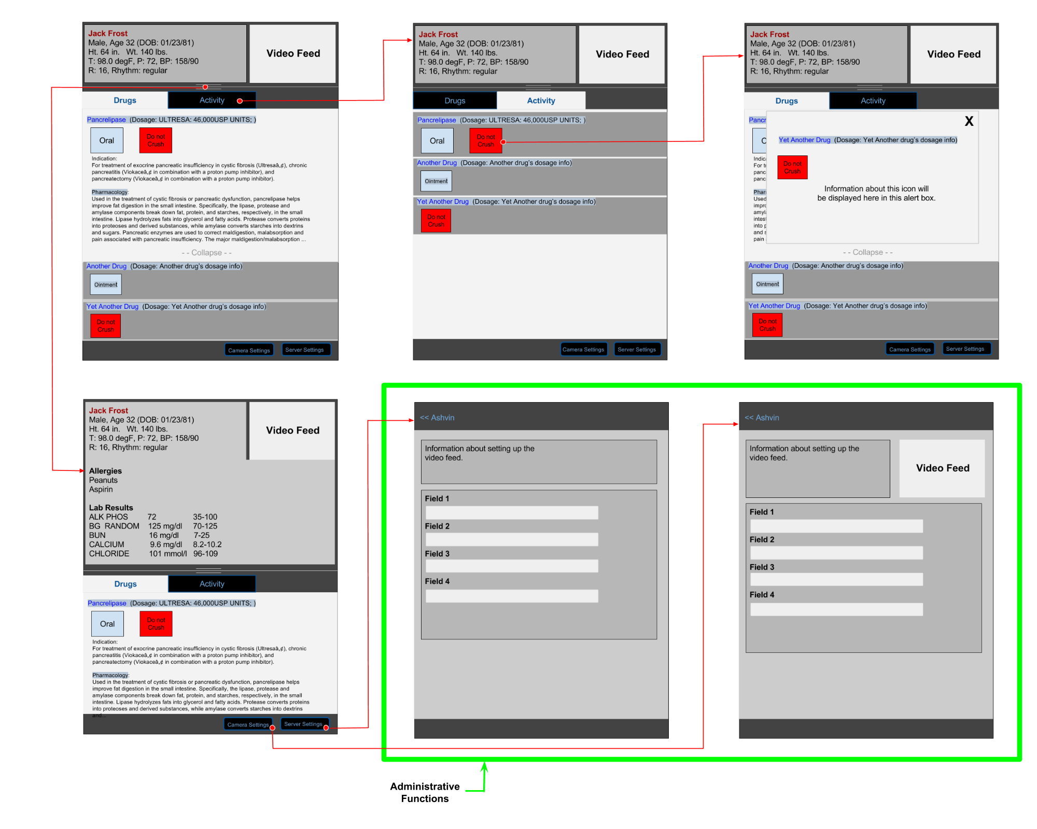Figure 1 : Ashvin GUI Flow Diagram

Launching the Client Application
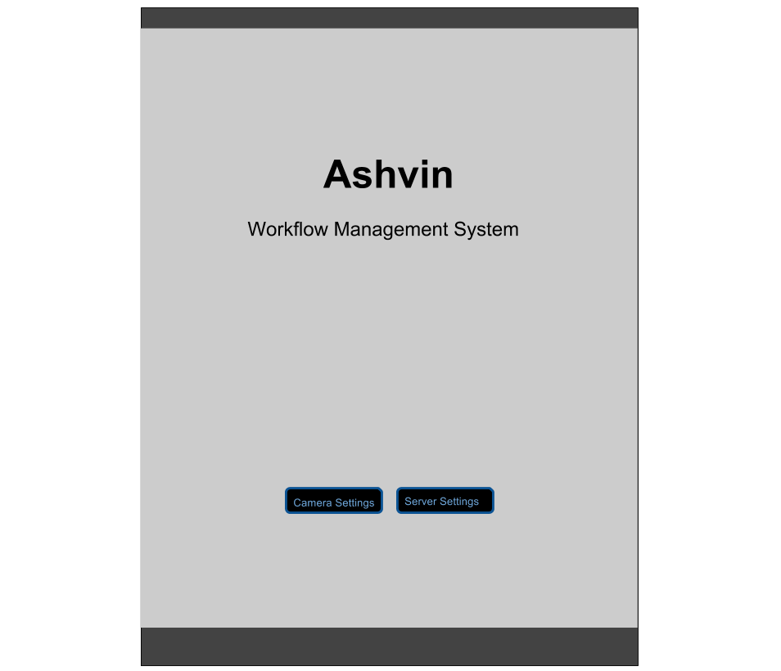Figure 2 : Ashvin Start Up

System Set Up

Camera Set Up
The user sets up the camera source by clicking on the Camera Settings button. Figure 3 shows the Camera Settings page.
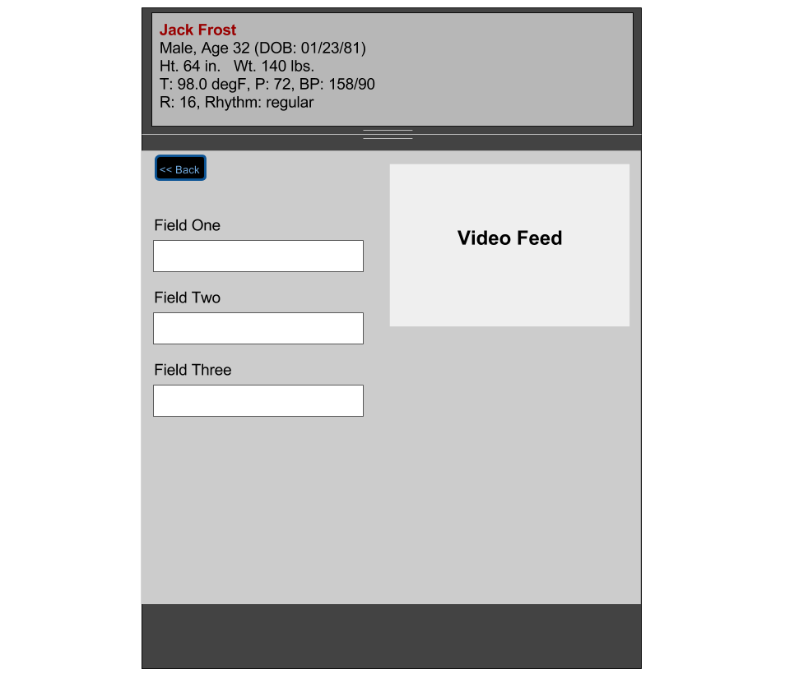Figure 3 : Camera Settings Page

Server Set Up
The user sets up the server by clicking on the Server Settings button. Figure 4 shows the Server Settings page.
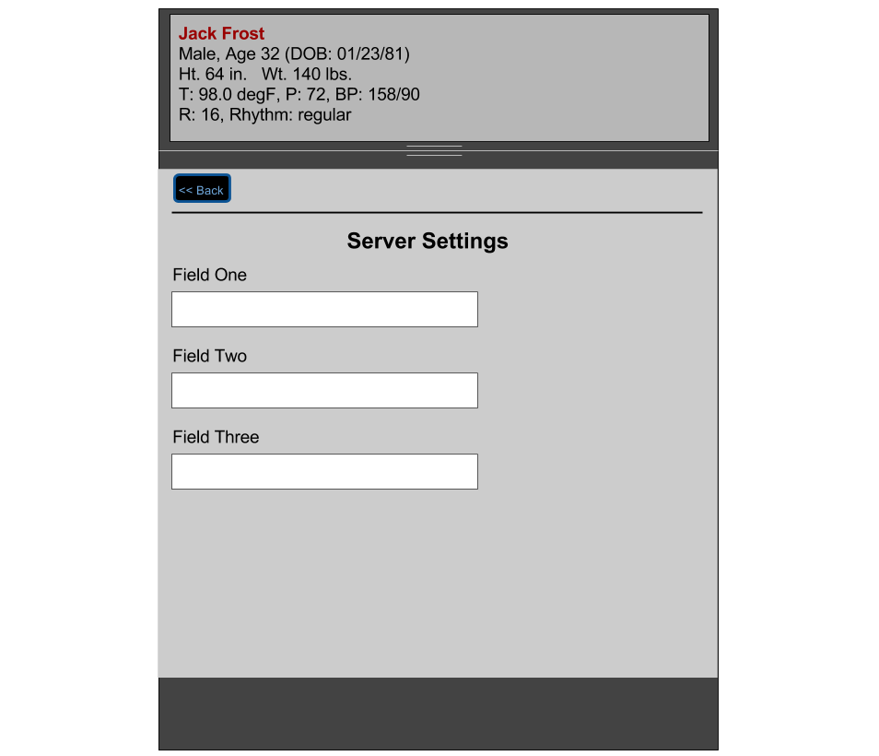Figure 4 : Server Settings Page

Display of Information

Patient Information
The Ashvin client GUI displays the results of any input event that results in a patient ID being entered into the mobile device running the client. The visual display of vital patient identification information is shown in Figure 5. This display also features a list of existing patient allergies, lab results and vitals. These data are obtained from the EHR via a wireless connection. The patient information display can be expanded or contracted as necessary by the user.
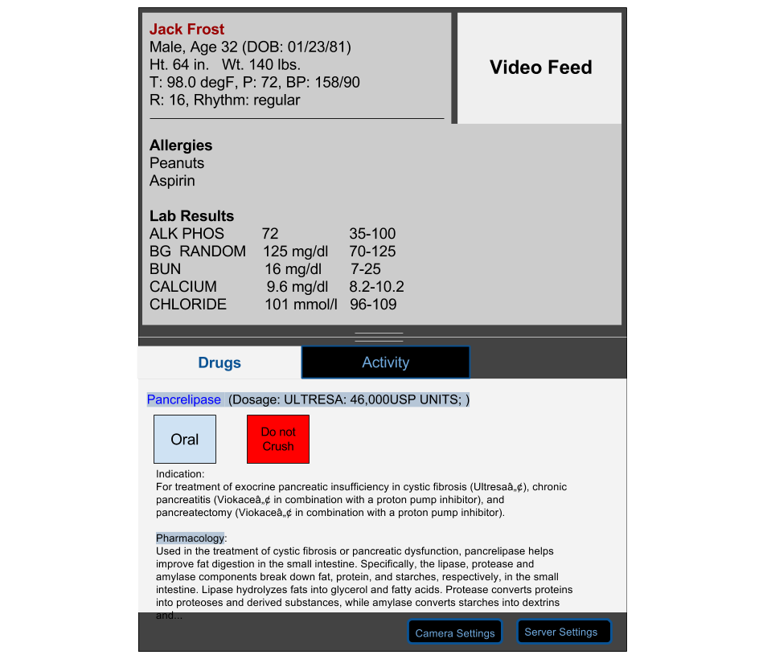Figure 5 : Patient Information Tab (Expanded View)

Patient Prescription
The Ashvin client GUI features a visual display of the patient's current drug prescription in the form of a list. Figure 6 shows the Drugs tab. This display also features icons that alert the user to constraints specific to each listed drug. The icons act as visual alerts to the user. Clicking on an icon brings up information defining the alert in more detail (See Figure 7).
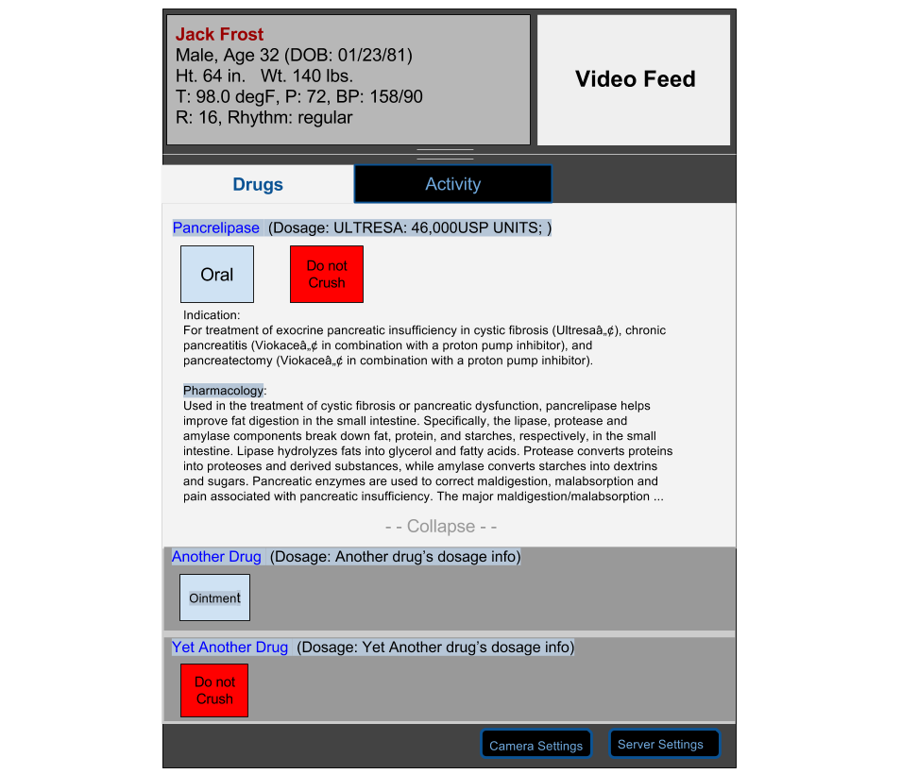Figure 6 : Patient Prescription Tab
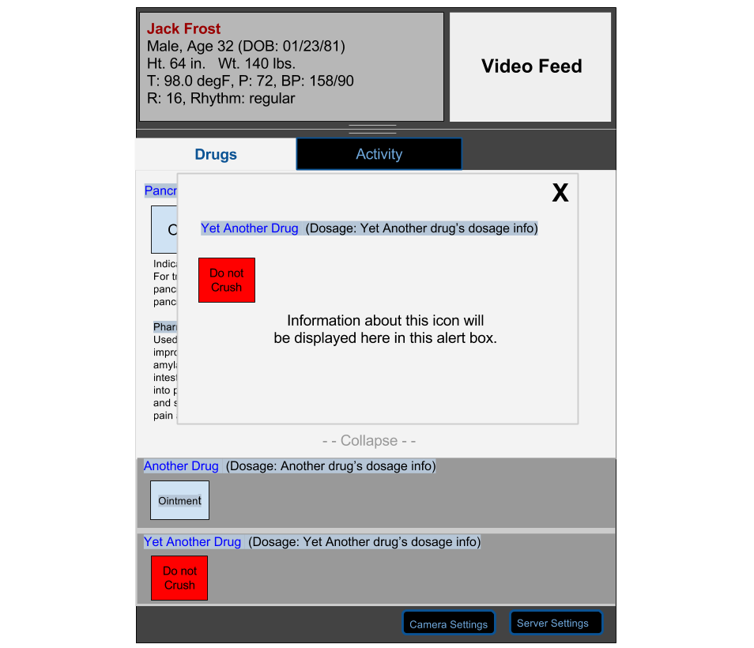Figure 7 : Drug Icon Pop Up Dialog

Input of Medication into System
The Ashvin client GUI features a visual display of the current activity of the camera and/or RFID scanning system in the form of a list. This list is similar to the patient prescription list described in Section- . Figure 6 shows the Drugs tab. This display also features icons that alert the user to constraints specific to each listed drug. The icons act as visual alerts to the user. Clicking on an icon brings up information defining the alert in more detail.
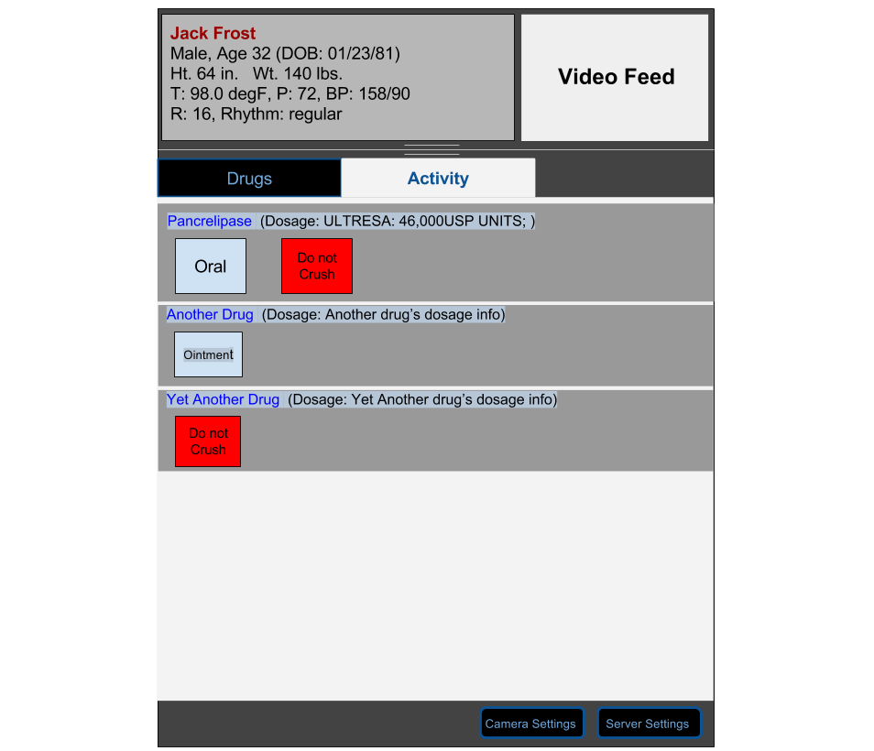Figure 8 : Scanning Activity Tab

User Stories
The functional requirements of the Ashvin system are defined as user stories. This section describes each user story. Each user story is assigned a unique identifier for reference purposes. Priorities are defined in .

Launching the Server Application
FR-006 | Launching the Server
 | As a user I want to launch the Ashvin server so that the Ashvin client can have access to logic that can perform processing of patient care data that are present in a specific patient care setting.
Priority | Must Have
Assumptions | - The Ashvin server application is located on a remote computer other than the one that runs the client.  - The server is accessible to the client within the patient care setting via a wireless connection.

Launching the Client Application
FR-001 | Launching the Client
 | As a user I want to launch the Ashvin client so that I can have access to the Ashvin system.
Priority | Must Have
Assumptions | The Ashvin client application is installed on the mobile device on which it is to run.

Assignment of Electronic Health Record (EHR) Source
FR-002 | Linking an EHR to the Ashvin Server
 | As a user I want to assign an EHR to the Ashvin server so that I can have input and output access to an electronic health record system.
Priority | Must Have
Assumptions | - The user can launch the Ashvin server application as per FR-006 or the server is running on the same computer as the client.  - An EHR is accessible via a wireless connection.

Assignment of Video Source
FR-003 | Linking a Video Source to the Ashvin Client
 | As a user I want to assign a video input source to the Ashvin client so that I can see the video that is being collected in the patient care setting.
Priority | Must Have
Assumptions | - The user can launch the Ashvin client application as per FR-001.  - A video feed is accessible to the client via a wireless connection.

FR-021 | Linking a Video Source to the Ashvin Server
 | As a user I want to assign a video input source to the Ashvin server so that I can receive dynamic input of patient care setting related data into the Ashvin client application.
Priority | Must Have
Assumptions | - The user can launch the Ashvin server application as per FR-006 or the server is running on the same computer as the client.  - A video feed is accessible to the server via a wireless connection.

Scanning a Patient into the Client
FR-004 | Passive Input of a Patient ID into the Ashvin Client Via Barcode
 | As a user I want to read a patient ID into the Ashvin client by explicitly scanning a barcode so that the Ashvin client can get data from the EHR for a specific patient that will be the subject of the current patient care setting.
Priority | Must Have
Assumptions | - The user can launch the Ashvin client application as per FR-001.  - The client is connected to a video source as per FR-003.

FR-007 | Active Input of a Patient ID into the Ashvin Client
 | As a user I want the client device to actively read a patient ID into the Ashvin client so that the Ashvin client can get data from the EHR for a specific patient that will be the subject of the current patient care setting.
Priority | Should Have
Assumptions | - The user can launch the Ashvin client application as per FR-001.  - The client is connected to a video source as per FR-003 or has RFID technology implemented and enabled.

FR-005 | System Successfully Recognizes a Patient ID
 | As a user I want to import EHR data into the Ashvin client for a specific patient from the EHR.
Priority | Must Have
Assumptions | - The user can launch the Ashvin client application as per FR-001.  - The client is connected to the Ashvin server.  - The user can input a patient ID into the client as per FR-004 or FR-007.  - The client is connected to an EHR.  - A patient with the scanned patient ID exists in the EHR.

Scanning Medication into the Client
FR-009 | Passive Input of a Medication ID into the Ashvin Client Via Barcode
 | As a user I want to read a medication ID into the Ashvin client by explicitly scanning a barcode so that the Ashvin client can get data from the EHR for a specific medication.
Priority | Must Have
Assumptions | - The user can launch the Ashvin client application as per FR-001.  - The client is connected to a video source as per FR-003.

FR-008 | Active Input of a Medication ID into the Ashvin Client
 | As a user I want the client device to actively read a medication ID into the Ashvin client so that the Ashvin client can get data from the EHR for a specific medication that exists in the current patient care setting.
Priority | Should Have
Assumptions | - The user can launch the Ashvin client application as per FR-001.  - The client is connected to a video source as per FR-003 or has RFID technology implemented and enabled.

FR-011 | System Successfully Recognizes a Medication ID
 | As a user I want to import EHR data into the Ashvin client for a specific medication from the EHR.
Priority | Must Have
Assumptions | - The user can launch the Ashvin client application as per FR-001.  - The client is connected to the Ashvin server.  - The user can input a medication ID into the client as per FR-008 or FR-009  - The client is connected to an EHR.  - A medication with the scanned medication ID exists in the EHR.

System Alerts

System Scans Object but Can Not Identify as a Patient or Medication
FR-012 | System Scans Object But Unsuccessfully Recognizes the Scan
 | As a user I want to receive an alert from the client if the scanned item is not recognized as a patient or medication so that I can know that there is an item in the environment that is a potential impediment to the scanning system.
Priority | Must Have
Assumptions | - The user can launch the Ashvin client application as per FR-001.  - The client is connected to the Ashvin server.  - The user can input a patient into the client as per FR-004 or FR-007.  - The user can input a medication into the client as per FR-008 or FR-009  - The client is connected to an EHR.  - There is an item in the patient care setting that does not represent a patient or medication.

System Scans Patient but No Such Patient Exists in the EHR
FR-013 | System Scans Patient But Patient Does Not Exist in the EHR
 | As a user I want to receive an alert from the client if the scanned patient does not relate to a patient in the EHR so that I can manually diagnose the problem.
Priority | Must Have
Assumptions | - The user can launch the Ashvin client application as per FR-001.  - The client is connected to the Ashvin server.  - The user can input a patient into the client as per FR-004 or FR-007.  - The client is connected to an EHR.  - The patient scanned is a legitimate patient but the patient is not present in the EHR.

System Scans Medication but No Such Medication Exists in the EHR
FR-014 | System Scans Medication But Medication Does Not Exist in the EHR
 | As a user I want to receive an alert from the client if the scanned medication does not relate to a medication in the EHR so that I can manually diagnose the problem.
Priority | Must Have
Assumptions | - The user can launch the Ashvin client application as per FR-001.  - The client is connected to the Ashvin server.  - The user can input a medication into the client as per FR-008 or FR-009.  - The client is connected to an EHR.  - The medication scanned is a legitimate medication but the medication is not present in the EHR.

System Detects Incorrect Match to Medication vs. Prescription
FR-015 | System Scans Medication But Medication Does Not Match Any Medication in the Patient Prescription Defined by the EHR
 | As a user I want to receive an alert from the client if the scanned medication does not relate to any medication in the patient prescription from the EHR so that I do not accidentally administer the incorrect medication to the patient.
Priority | Must Have
Assumptions | - The user can launch the Ashvin client application as per FR-001.  - The client is connected to the Ashvin server.  - There is a patient entered into the client.  - The user can input a medication ID into the client as per FR-008 or FR-009.  - The client is connected to an EHR.  - The patient has an active prescription in the EHR.

System Detects Incorrect Match to Medication Dose vs. Prescription
FR-016 | System Detects Medication Administration Event but the Medication Dose Does Not Match the Prescribed Dose in the Patient Prescription Defined by the EHR
 | As a user I want to receive an alert from the client if the scanned medication's dose does not match the dose prescribed in the patient prescription from the EHR so that I do not accidentally administer the incorrect dose to the patient.
Priority | Should Have
Assumptions | - The user can launch the Ashvin client application as per FR-001.  - The client is connected to the Ashvin server.  - There is a patient entered into the client.  - The scanned medication matches a medication in the EHR.  - The user can input a medication into the client as per FR-008 or FR-009.  - The client is connected to an EHR.  - The patient has an active prescription in the EHR.

System Detects Incorrect Match of Medication Route vs. Prescription
For User Story FR-017, a Medication Route refers to the manner of administration for the medication. An example of an incorrect administration route would be if a patient has to receive a medication in pill form as per the prescription but receives the medication in liquid form.
FR-017 | System Detects Medication Administration Event but the Medication Route Does Not Match the Recommended Route Defined in the Prescription's Instructions As Per the EHR Data
 | As a user I want to receive an alert from the client if I am administering a medication via the wrong route defined by the prescription so that I do not harm the patient.
Priority | Could Have
Assumptions | - The user can launch the Ashvin client application as per FR-001.  - The client is connected to the Ashvin server.  - There is a patient entered into the client.  - The scanned medication matches a medication in the EHR.  - The user can input a medication into the client as per FR-008 or FR-009.  - The client is connected to an EHR.  - The prescription has specific instructions relating to the administration route.

System Detects Incorrect Match to Time Administered vs. Prescription
FR-018 | System Detects Medication Administration Event and the Current Time Clashes with the Administration Time Defined in the Prescription's Instructions As Per the EHR Data
 | As a user I want to receive an alert from the client if I am administering a medication at the incorrect time so that I do not harm the patient.
Priority | Should Have
Assumptions | - The user can launch the Ashvin client application as per FR-001.  - The client is connected to the Ashvin server.  - There is a patient entered into the client.  - The scanned medication matches a medication in the EHR.  - The user can input a medication into the client as per FR-008 or FR-009.  - The client is connected to an EHR.  - The medication has specific instructions relating to the administration time.

System Detects Incorrect General Route
For User Story FR-019, a General Route refers to the manner of administration for the medication as described in – . An example of an incorrect general route would be if a patient has to receive a medication in pill form as per the medication's instructions but receives the medication in liquid form.
FR-019 | System Detects Medication Administration Event but the Administration General Route Does Not Match the General Route Defined in the Medication's Instructions As Per the EHR Data
 | As a user I want to receive an alert from the client if I am administering a medication via the incorrect general route so that I do not harm the patient.
Priority | Could Have
Assumptions | - The user can launch the Ashvin client application as per FR-001.  - The client is connected to the Ashvin server.  - There is a patient entered into the client.  - The scanned medication matches a medication in the EHR.  - The user can input a medication into the client as per FR-008 or FR-009.  - The client is connected to an EHR.  - The medication has general instructions relating to the administration route.

System Detects Correct General Route but Incorrect Specific Route
For User Story FR-019, a General Route refers to the manner of administration for the medication as described in – . An example of a correct general route but incorrect specific route would be if a patient has to receive a medication via IV form in a specific IV but receives the medication in the incorrect IV.
FR-020 | System Detects Medication Administration Event but Even Though the Administration General Route Matches the General Route Defined in the Medication's Instructions As Per the EHR Data, the Specific Route Does Not Match
 | As a user I want to receive an alert from the client if I am administering a medication via the correct general route but incorrect specific route so that I do not harm the patient.
Priority | Could Have
Assumptions | - The user can launch the Ashvin client application as per FR-001.  - The client is connected to the Ashvin server.  - There is a patient entered into the client.  - The scanned medication matches a medication in the EHR.  - The user can input a medication into the client as per FR-008 or FR-009.  - The client is connected to an EHR.  - The medication has general instructions relating to the administration route.

Non Functional Requirements
[TODO]

Security
[TODO]

Reliability
[TODO]

Durability
[TODO: Battery stuff can go in here]

Speed
[TODO: Access speed needs to be quantified]

Portability
[TODO]

Expandability
[TODO]

Testability
[TODO]

Documentation

Design Document
[TODO]

User Manual
[TODO]

Administrative Manual
[TODO]

System Evolution
[TODO]

